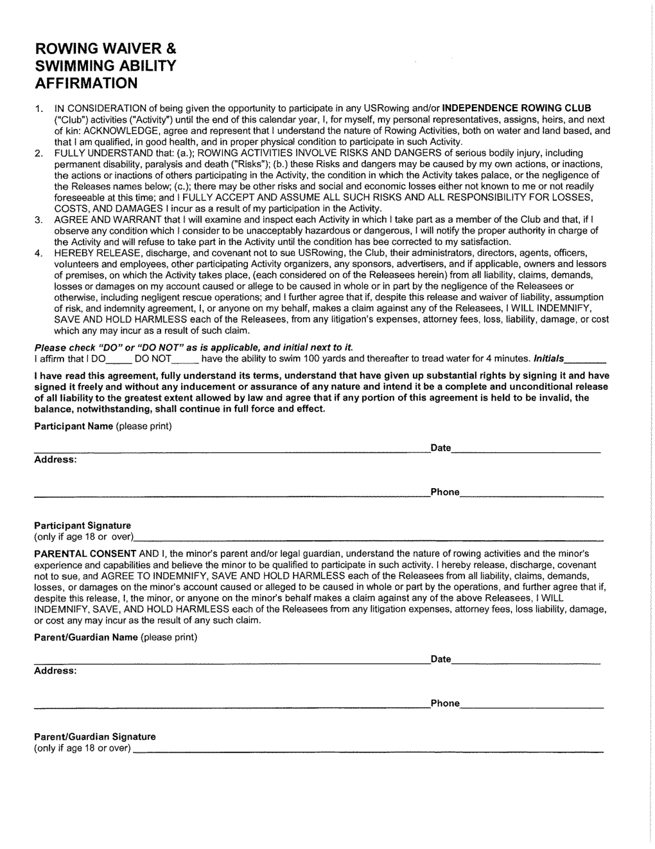

Date of Birth _____________ E-mail ____________________________

